MINI PROJECT REPORT: RULE-BASED CURRICULUM ASSISTANT
1. Introduction
The aim of this mini project was to develop a simple rule-based chatbot called the Rule-Based Curriculum Assistant. The chatbot was designed to answer common student questions about course information, such as assignment deadlines, notebooks, datasets, examinations, and other curriculum-related topics. Unlike modern AI chatbots, the system does not use a Large Language Model (LLM). Instead, it uses keyword matching and predefined responses.
The application was developed using Python and Streamlit, which provides an interactive web-based interface for the chatbot.
2. Objectives
The main objectives of the project were to:
- Create a chatbot using a keyword-based approach.
- Store keywords and their corresponding responses in a Python dictionary.
- Provide an interactive chat interface using Streamlit.
- Maintain conversation history during a session.
- Provide a fallback response when the chatbot does not recognise a keyword.
- Include a Clear Conversation button.
- Display the number of messages exchanged during the conversation.
3. System Implementation
The chatbot begins by importing the Streamlit library:
import streamlit as st
A dictionary called responses is then created to store the chatbot's knowledge. Each keyword is associated with a predefined response. For example, the keyword "deadline" is linked to a response concerning assignment deadlines, while "dataset" provides information about course datasets.
The program uses st.session_state to store conversation messages. This is important because Streamlit reruns the application whenever the user interacts with it. Session state ensures that previous messages are not lost during these reruns.
The user's question is obtained using:
prompt = st.chat_input("Ask a question...")
Before matching keywords, the input is converted to lowercase using:
prompt_lower = prompt.lower()
This allows the chatbot to recognise keywords regardless of whether the user types them in uppercase or lowercase.
The program then loops through the dictionary and checks whether any keyword appears in the user's question. If a match is found, the corresponding predefined response is returned. If no keyword is found, the chatbot provides a fallback message informing the user that it does not recognise the question.
4. User Interface
Streamlit was used to create the graphical interface of the application. The st.chat_message() function displays messages from both the user and the assistant in a conversational format.
A sidebar was also included in the application. It contains a Clear Conversation button, which removes all stored messages by resetting the message list to an empty list.
The sidebar also displays a message counter using:
len(st.session_state.messages)
This allows the user to see how many messages have been exchanged in the current session. 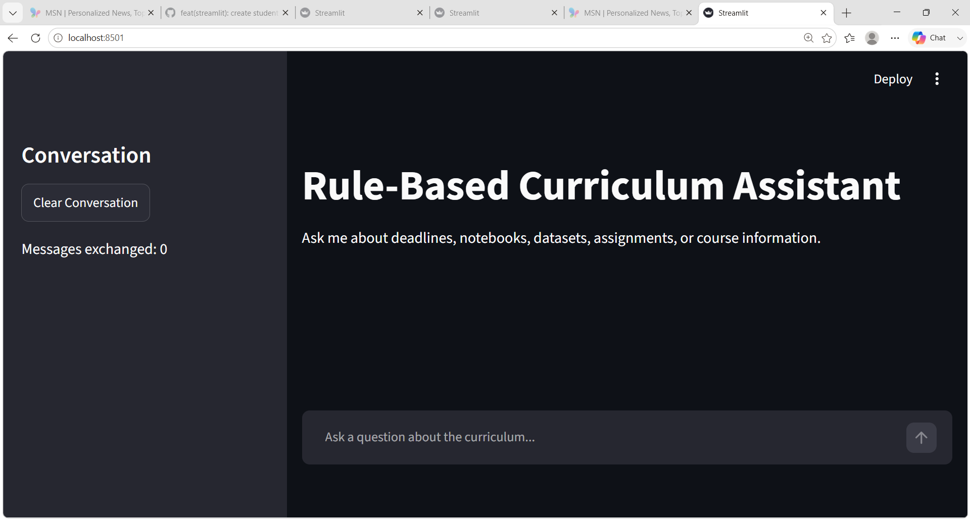
5. Testing and Results
The chatbot was tested using different types of questions. Questions containing recognised keywords produced the appropriate predefined responses. For example, a question containing "deadline" resulted in the deadline response, while a question containing "dataset" returned information about datasets.
The system was also tested with questions containing uppercase letters to confirm that the lowercase conversion worked correctly. Unknown questions produced the fallback response rather than leaving the chatbot without an answer.
The Clear Conversation function was tested successfully, and the message counter was updated as messages were added and reset when the conversation was cleared. 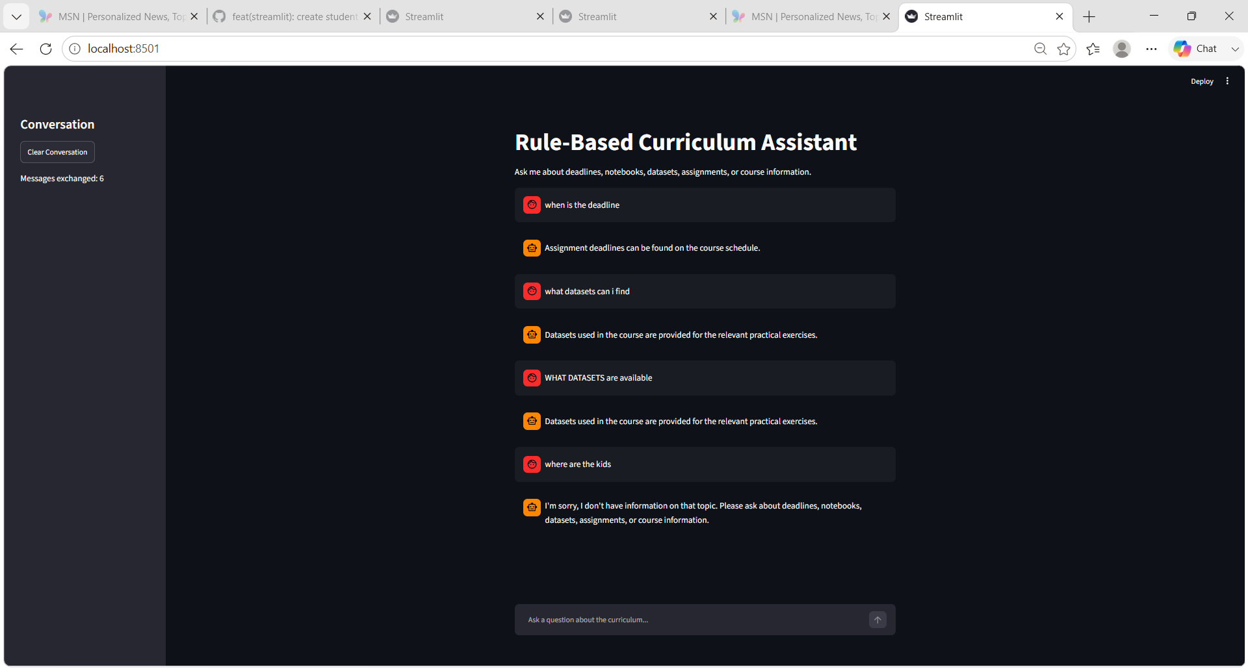
6. Conclusion
The project successfully demonstrated how a simple rule-based chatbot can be developed using Python and Streamlit. The system uses keyword matching rather than artificial intelligence or machine learning, making it relatively simple to implement and understand.
Although the chatbot is limited because it can only respond to predefined keywords, it provides a useful foundation for understanding conversational interfaces, dictionaries, loops, conditional statements, session state, and Streamlit components. The system could be improved in the future by adding more keywords and responses, handling synonyms, and eventually integrating a natural language processing model or LLM to understand more complex student questions.

